Student
Course
Professor
Date
Types of plants
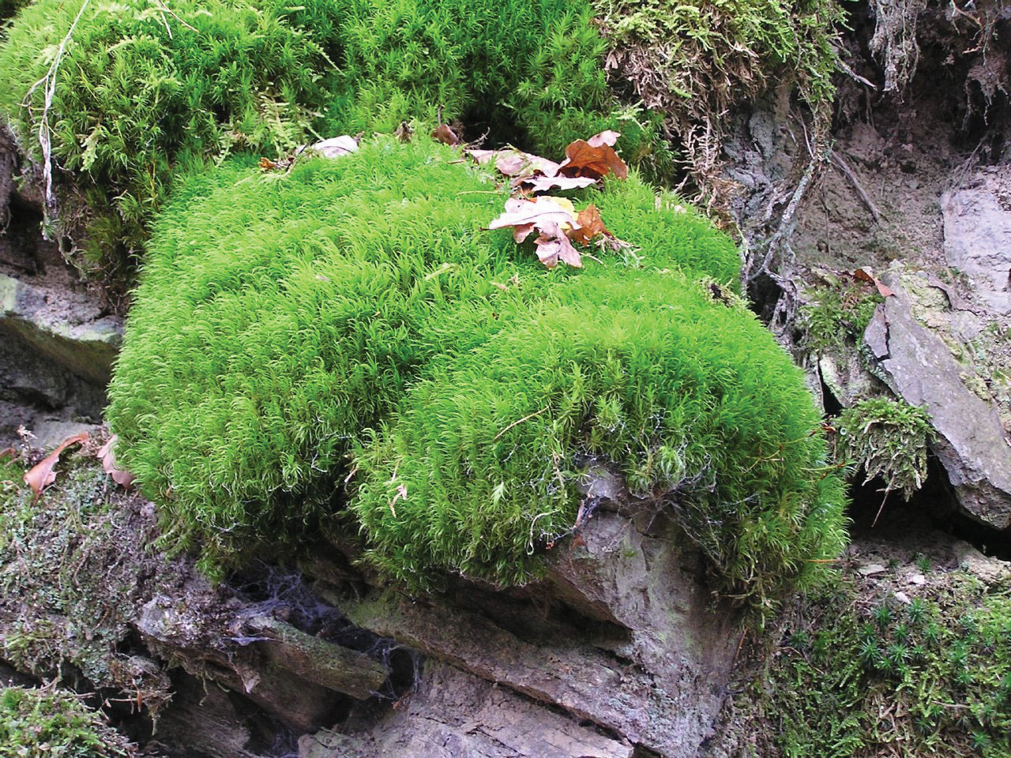
Moss Plant
- They are small non vascular and flowerless plants.
- They are usually dense, clump plants or mats and are found in dense and shady areas.
- The moss gametophytes have got simple stems which are usually upright and prostate.
- They reproduce by means of spores but not seeds.
- They have simple leaves, single celled with not internal air spaces.
- Moss plants don’t have roots but rhizoids which they use to attach themselves on the ground.
- The spores bearing sporophytes are short usually short lived and depends on their gametophytes for nutrients and water
- The image was taken from https://www.britannica.com/plant/moss-plant

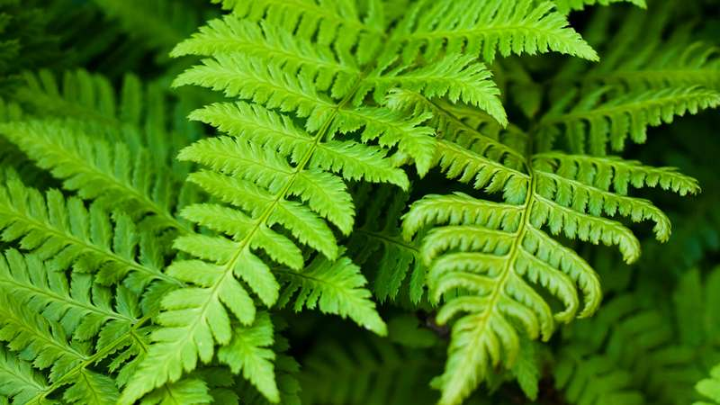
Fern
- Fern is a vascular plant i.e. has xylem and phloem and reproduces by means of spores rather than seeds.
- Ferns such as the walking fern can reproduce in a vegetative manner.
- It is a non flowering plant.
- Most ferns can grow to a height of about 12 inches to 6 feet depending on the growing environment they are in.
- Fern have roots, stems and leaves which they use to get nutrients and water.
- Their vascular tissues allow them to adapt easily to dry lands.
- The tropical ferns usually grow well in an indirect light environment.
- They grow well in tropical and subtropical climate regions.
- https://www.tennesseewholesalenursery.com/wholesale-poly-ferns-for-sale/

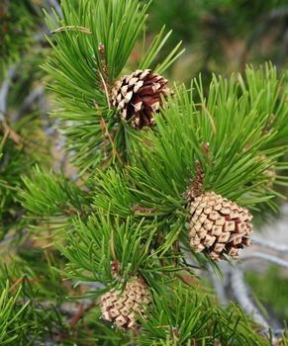
Gymnosperms (Pine Tree)
- The gymnosperms are non flowering plants that reproduce by means of cones and seeds.
- Gymnosperm means the naked seeds (seeds are not encased in the ovary) but are exposed in a leave like structures by the name of bracts.
- These plants are found in cold and snowy regions.
- Their leaves are needle like.
- The plant is perennial and woody hence they form trees and a bush.
- These plants don’t have ovary, stigma and style.
- For they don’t have stigma, they are pollinated directly by means of the wind.
- Cones are formed with reproductive structures.
- The plants have vascular tissues that help them in transportation of foods, water and nutrients.
- Their seed have got endosperm used to store food for development and growth.
- Their xylems don’t have vessels and their phloem don’t have the companion cell and sieve tubes

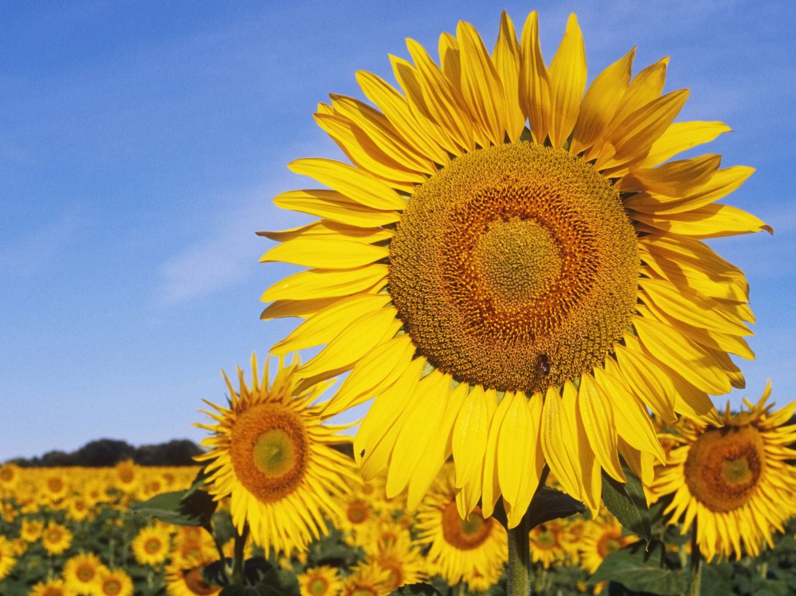
Monocot Angiosperm (Monocotyledons) (sunflower)
- These are grass or grass like flowering plants.
- Major examples of monocotyledon include maize, wheat, onions, barley, apples
- Their seeds contain only one embryonic seeds i.e. cotyledon.
- They are about 60,000 species of monocotyledon plants.
- Their pollen have single furrow or pore.
- Their flowering parts are in multiples of three.
- These plants grow in a wide range of habitats.
- The stem vascular bundles are scattered.
- The roots are adventitious.
- They don’t have secondary growth hence they does not produce wood or barks.

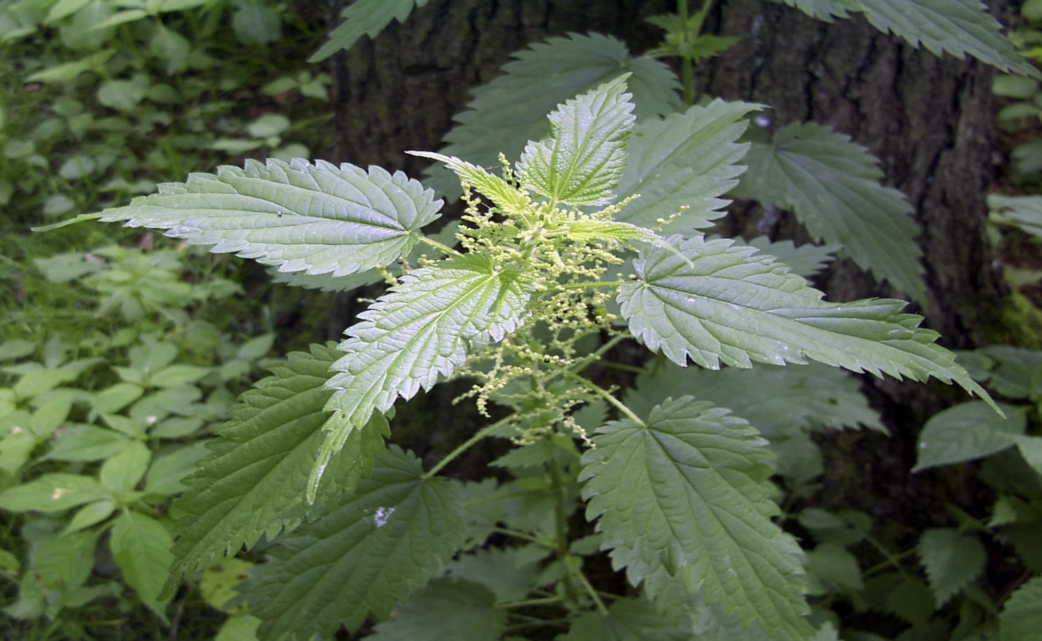

Dicotyledons Angiosperm (Urticales)
- The plants are one of the two groups of the flowering plants.
- The plants have embryo with two cotyledons.
- Their pollens have three furrows or pores.
- Their flowering plants are in multiples or three or fours.
- Their major leaves veins are reticulated.
- The stem vascular bundles are in a ring.
- Secondary growth in these plants is present.
- They grow well in terrestrial and aquatic habitats.

